**MITS 6001**

**CLOUD COMPUTING**

Assignment-2

Name: Ranjeeth Kumar Sheshala.

ID: 42328.

College: Victorian Institute of Technology.

Lecturer: Dinesh Pandey (Melbourne).

STEP 1: Creating the Virtual Machine on Ubuntu server with SSH,HTTP,HTTPS network ports accesible for Public lnternet.

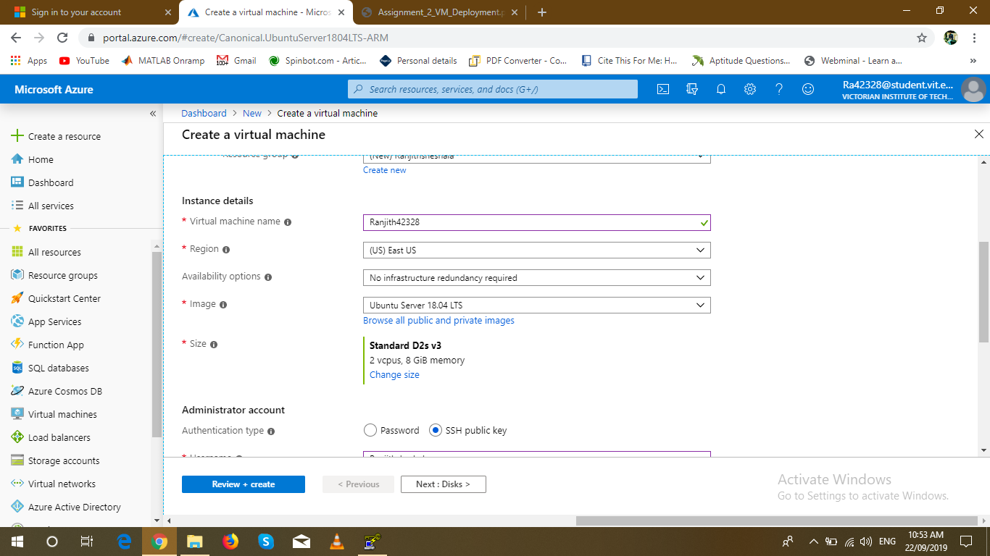

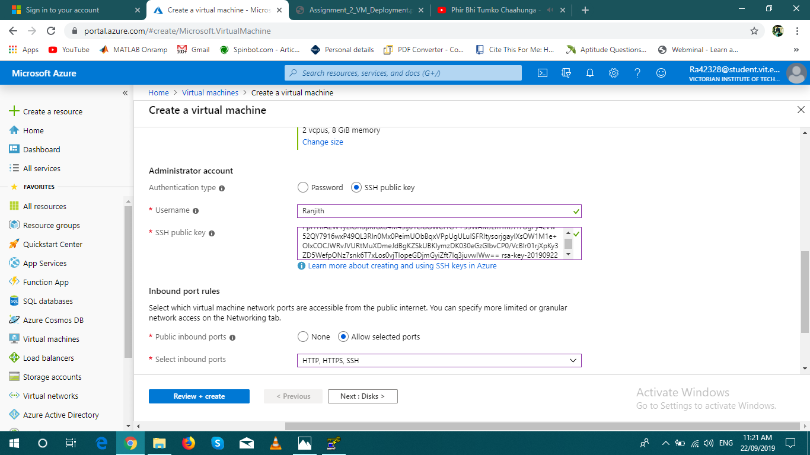

STEP 2:

* Generate the putty key from putty key generator
* Save the public key and private key .
* Copy the public key and paste it in the SSH public key administrator.

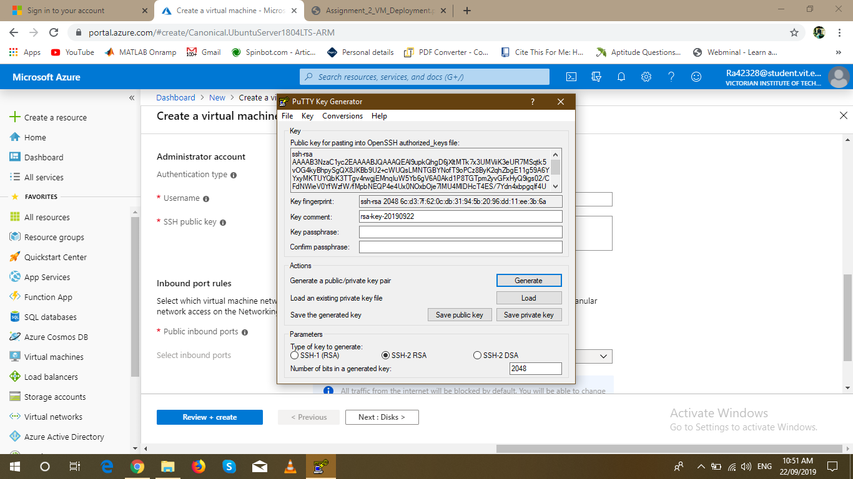

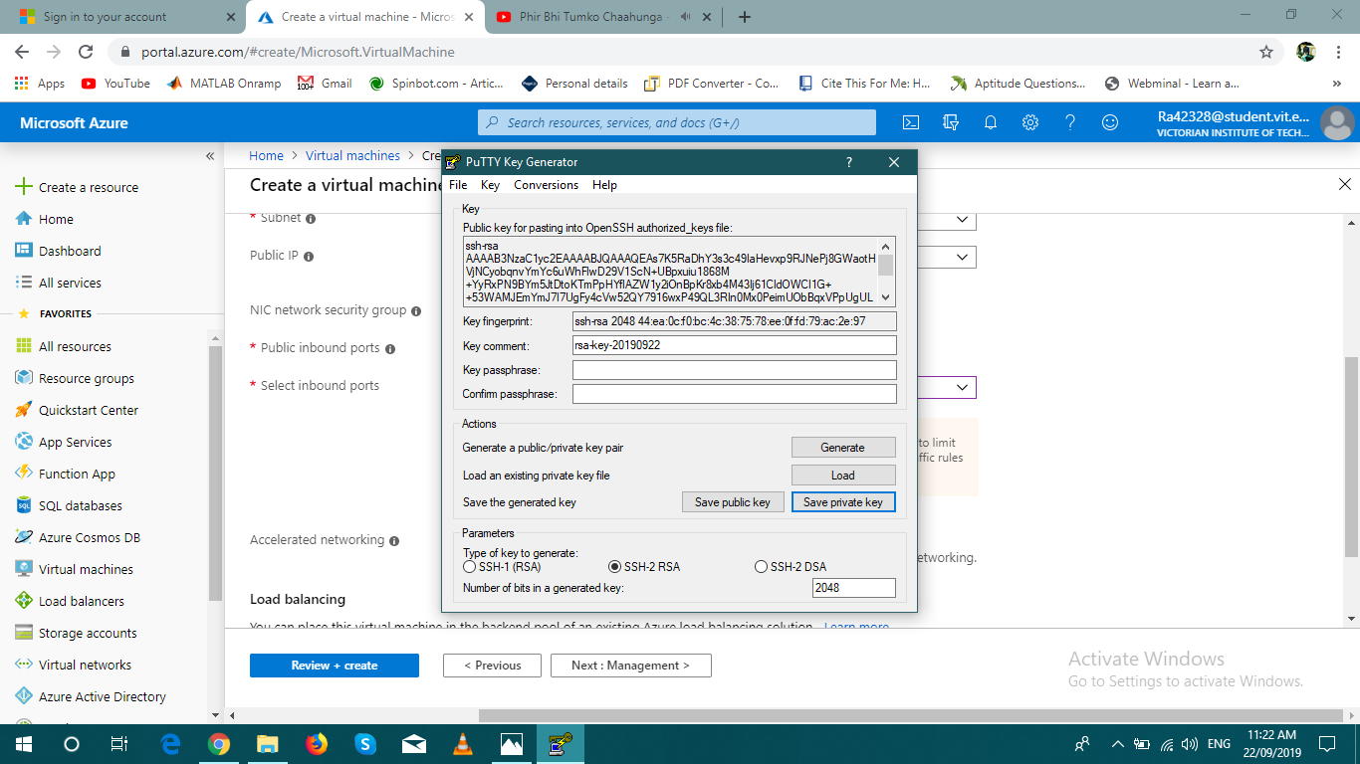

STEP 3: Deployment of virtual machine is done and successfully created an VM account with resource group Ranjithsheshala and IP Address 13.68.231.66 .

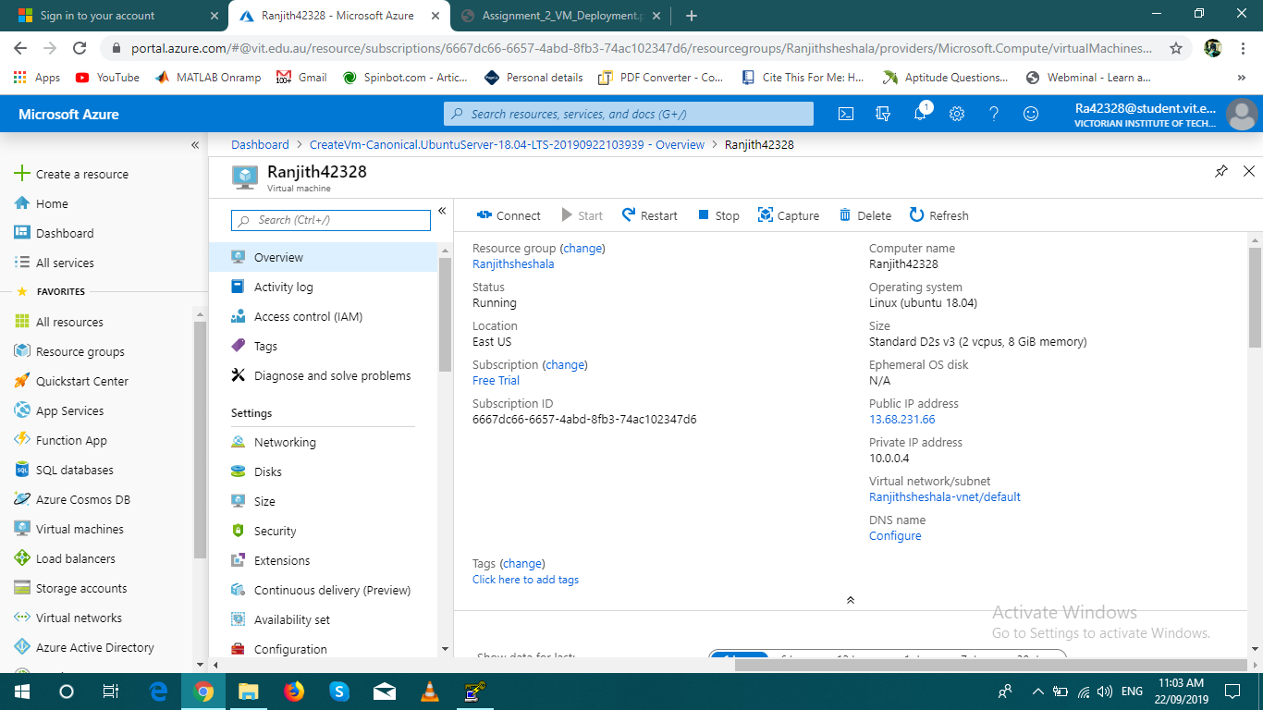

STEP 4: Open Putty configuration

* Copy the IP address and paste it in the Host name.
* Go to SSH authorisation and browse for the private key.
* Next go to session and save the session with Ubuntu name .
* Click on open then login page is opened.

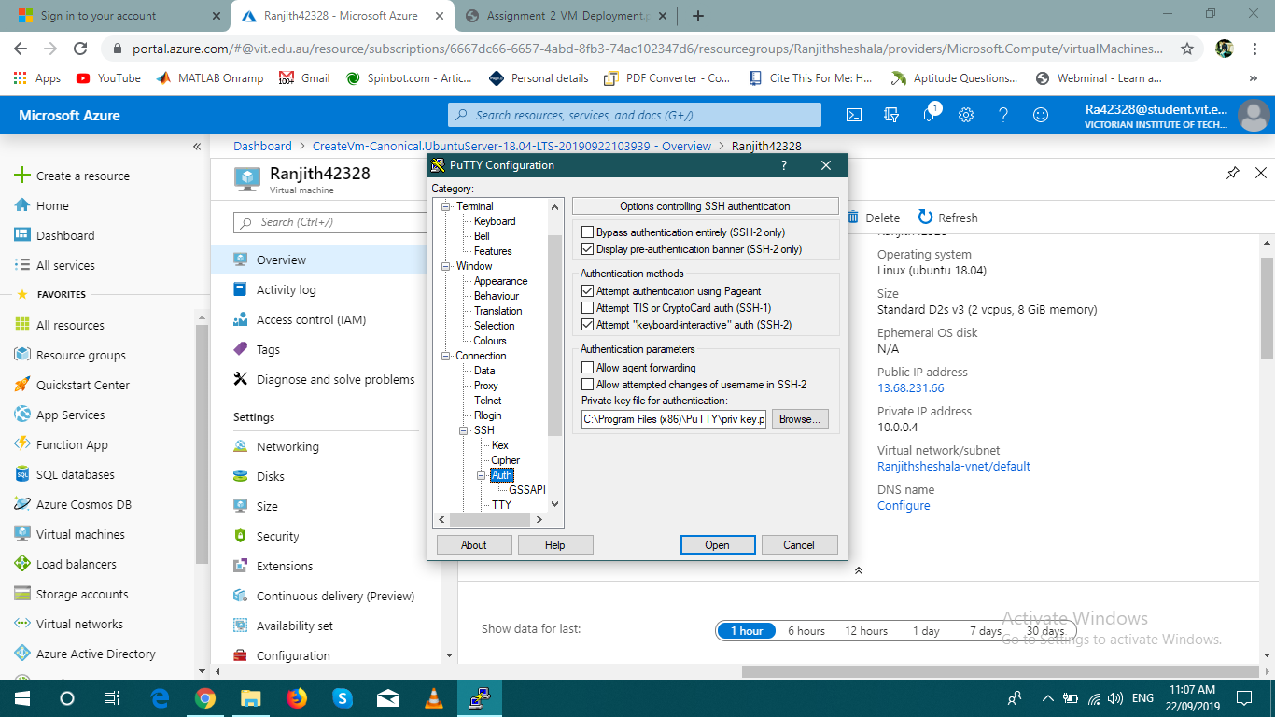

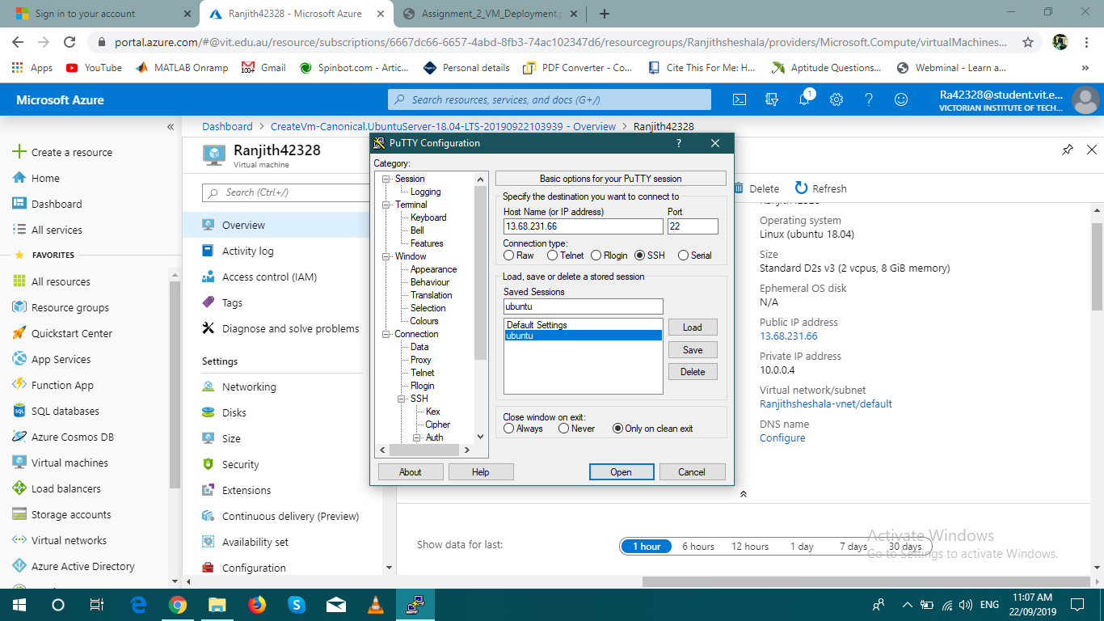

STEP 5: Login as open resource group name Ranjithsheshala .

Result: Result is shown as below screen window.

